Housing Affordability Crisis in Canada

Ashley Miller and Durva Parmar
University of Northern British Columbia
ECON 204: Contemporary Economic Issues
Professor Muhebullah Karimzada
April 4th, 2025

The Housing Affordability Crisis

The housing affordability crisis is a global issue that is impacting individuals all over the world. From Australia, to China, all the way to North America, housing prices are increasing at unprecedented rates, having serious consequences for their inhabitants. This phenomenon rings true across Canada, with cities such as Vancouver and Toronto ranking in third and eleventh place for the least affordable English-speaking markets in 2023, respectively (et al https://www.demographia.com/dhi.pdf). However, less populated areas are also feeling the impact of the housing affordability crisis. In the United States, small cities like Bozeman, Montana, experienced a 28% increase in median property value between 2021 and 2022 https://datausa.io/profile/geo/gallatin-gateway-mt#housing. Similarly, in Canada, small cities such as Prince George saw the average selling price increase by $86,361 from December 2019, along with an approximate rise of 19.41% in the number of units sold. https://www.vmcdn.ca/files/princegeorgematters/pgc-files/bcnreb-2021-year-end-news-release.pdf?utm_source=prince%20george%20citizen&utm_campaign=prince%20george%20citizen%3A%20outbound&utm_medium=referral. This illustrates that the housing affordability crisis is a global issue, impacting both large and small communities alike.
The housing affordability crisis is an issue that is influenced by multiple factors. In Canada, the situation worsened during the onset of the global pandemic. However, COVID-19 is only partially responsible for the ongoing crisis. In addition to changes in consumer buying behaviours shaped by COVID-19, the housing crisis in Canada is also driven by the Bank of Canada’s monetary policies and the imbalance between housing supply and demand. Additionally, population growth and inadequate government intervention are also contributing factors. This complex issue impacts both urban and rural communities in Canada and around the world. It is imperative for governments to respond effectively to this crisis, so they can mitigate the negative consequences of housing unaffordability and support their citizens.
Body 2:The Impact of COVID-19 on Consumers Buying Behaviour
In 2020, the global pandemic has a significant impact on the Canadian housing market. Although there were other factors contributing to the housing affordability crisis at this time, COVID-19 had its own notable effects. One of the most noteworthy effects is the shift in consumer buying behaviour. Prior to 2020, individuals were restraint by their geographical requirements of work, school, and other commitments that required them to be in person or located in a specific area. However, as COVID-19 escalated to a global pandemic, the percentage of Canadians working from home rose drastically from just 7.1% to 40% in April 2020 (Morissette, 2024). This 32.9% increase in remote work led to a significant change in consumer buying behaviour, where households required more room to accommodate workspace needs.
This significant disruption posed by COVID-19 ultimately led individuals to seek larger living accommodations. This new need for more space was to accommodate home offices, educational needs, and other at home requirements. This resulted in a sudden increase in demand for bigger houses, as many individuals who were not actively seeking different living arrangements found their current homes unsuitable for their new work-life circumstances. By increasing demand of larger homes, without increasing the supply, the price home buyers were willing to pay also increased. This phenomenon was also escalated by the Bank of Canada’s monetary policy which will be discussed later in this paper.
Moreover, as the rise in individuals working from home increased, their location requirements decreased. Individuals were no longer limited to specific work or school locations. This allowed potential homebuyers to relocate to more affordable areas, which in turn increased housing prices in those areas. Additionally, the increase in demand without a significant increase in supply ultimately rose prices, not only in larger houses, but in smaller homes such as mobile homes and condominiums. This is illustrated with the expectation of homeowners and the price they expect to see when they sell their home. The average dollar value that homeowners expect to see when selling their homes has increased on average by 41.01% from 2016 to 2021. This overall increase includes single-detached homes, which saw a significant rise of approximately 38.82%, apartments, which increased by approximately 38.86%, and other types of single-detached homes, which saw the highest increase of 45.36% (Government of Canada, Statistics Canada, 2023). Refer to Appendix F for charts and calculations. These are significant changes that exasperate our housing market affordability crisis in Canada.
Body 3: Current Impact of High Household Rates
These days families are facing a lot of pressure on household expenses. As nowadays bills for essentials, such as electricity, water, and other types of taxes are rising, because of which men are finding it tough to make ends meet. Getting back on food and other basic expenses is getting too common for people (MNP Debt, 2024). People are coming up with new innovative ideas like sharing rides buying in bulk and even living together to cut costs since thing have become so serious more people are using food banks and now about 21% of those relying on this services are two parent households, which is a noticeable jump, compared to previous years (CTV News, 2024) costing sky, where people were hoping for a financial bounce back after COVID-19 however it got even worse than before with inflation and rising interest rates. Families found themselves struggling again and at first while panda makeover, support, and assistance checks helped ease the burden (Global news, 2024). Currently as we work towards recovering from the pandemic we are encountering fresh issues related to social welfare rates and concerns about wages in certain areas(The Sun, 2024). In addition, mortgage rates have risen, making it hard for me class families to afford a home(news.com.au,2024). Overall, financial difficulties for households haven’t really eased up since the pandemic with inflation, rising interest rates and stagnant wages. Many families are finding it tough to make ends meet. This situation is pushing them to cut back on little luxuries delay, delay, significant life changes and reconsider their long-term financial plans.
Body 4: Monetary Policy on Housing Market
The Bank of Canada's decisions about interest rates have really shaped the Canadian housing market both before and during the COVID-19 pandemic, and in its aftermath. Before 2020, the Bank increased interest rates in 2017 to try and cool down the hot housing market, especially in places like Toronto and Vancouver. Even though higher rates made mortgages pricier, housing prices kept climbing because demand was strong and supply was limited. Plus, when mortgage stress tests were rolled out in 2018, buyers had to qualify at higher rates, which reduced their purchasing power and slowed down sales. Still, the issue of affordability continued to be a struggle for many.
When the COVID-19 pandemic hit, the Bank of Canada drastically cut interest rates to a historic low of 0.25% in March 2020 to boost the economy. These emergency cuts made mortgages more affordable and boosted housing demand, especially in suburban and rural areas. On top of that, the central bank's quantitative easing (QE) policies added liquidity to the financial system, which really helped home sales take off and increased market competition. During this time, home prices skyrocketed as buyers rushed to take advantage of those low borrowing costs.
After the pandemic, the Bank of Canada changed gears by aggressively raising interest rates starting in 2022 to fight inflation, reaching 5.00% by 2023. These hikes considerably raised mortgage costs, slowing down demand but not really bringing down home prices, mainly because of ongoing supply shortages. Even with the higher interest rates, affordability continued to be a big concern, as demand still outstripped available housing. Also, the rising borrowing costs made it harder for new housing projects to get off the ground, since developers faced increased financing costs, further tightening the supply. Experts suggest that while raising interest rates can help stabilize inflation, it’s not enough to fix Canada's deep-rooted housing affordability crisis.

Body 5: Policy Recommendations to Reduce Negative Impact of the Housing Affordability Crisis. Ideas: Increase Canadian residents ability to produce homes, aka increase supply; decrease the flow of immigration to decrease demand; …

The Conclusion:
In a nutshell, the struggle to find affordable housing is a major issue that’s affecting people all around the globe from Australia to China and all the way to North America. Prices for homes are skyrocketing at an unprecedented pace and this is having serious consequences for those who live there.
The overall increase in housing prices includes a notable rise in single detached homes, which have seen the highest jump. These changes are making the housing affordability crisis in Canada even worse. Since the pandemic, many households are still struggling financially due to inflation, rising interest rates, and stagnant wages. Families are finding it increasingly difficult to manage their budgets, leading them to cut back on small luxuries and postpone important life decisions while rethinking their long-term financial plans. Additionally, the rising costs of borrowing are making it tough for new housing projects to launch, as developers face higher financing costs, which further tightens supply. While raising interest rates may help stabilize inflation, it’s clear that it’s not enough to solve Canada’s deepening housing affordability problem.
References
References
CTV News. (2024). More Canadian households struggling to put food on the table due to high cost of living. Retrieved from https://www.ctvnews.ca/canada/more-canadian-households-struggling-to-put-food-on-the-table-due-to-high-cost-of-living-report-1.6616564
Demographia (2024) International Housing Affordability. https://www.demographia.com/dhi.pdf
Gallatin Gateway, MT | Data USA. (n.d.-b). https://datausa.io/profile/geo/gallatin-gateway-mt
Global News. (2024). Cost of living crisis impacting families and children's activities. Retrieved from https://globalnews.ca/news/10730717/kids-cost-of-living-inflation-interest-rate-poll
The Sun. (2024). New social welfare rates and wage warnings as cost of living continues to rise. Retrieved from https://www.thesun.ie/money/14860908/social-welfare-rates-wage-warning-fuel-allowance-cut
Government of Canada, Statistics Canada. (2023, October 4). Focusing on a selected geographic area, this product presents data highlights for each of the major releases of the 2021 census. these data highlights are presented through text, tables and figures. A map image of the geographic area is also included in the product. the geographic levels presented in this product include Canada, provinces and territories, census metropolitan areas, census agglomerations, census divisions and census subdivisions. Focus on Geography Series, 2021 Census - Canada. https://www12.statcan.gc.ca/census-recensement/2021/as-sa/fogs-spg/page.cfm?topic=7&lang=E&dguid=2021A000011124
MNP Debt. (2024). Rising cost of living forces Canadians to make sacrifices. Retrieved from https://mnpdebt.ca/en/resources/mnp-debt-blog/rising-cost-living-canadians-make-sacrifices
News.com.au. (2024). Mortgage horror exposes financial struggles in Australia. Retrieved from https://www.news.com.au/finance/economy/struggling-mums-viral-admission-reveals-just-how-tough-aussies-are-doing-it/news-story/837b5943787200963363c8a0764011e7
Morissette, R. (2024, January 18). The COVID-19 pandemic led to a substantial increase in work from home in Canada. this presentation synthesizes what has been learned to date regarding this increase in work from home and documents its potential implications for productivity, employee retention, commuting, greenhouse gas emissions, and public transit use.Government of Canada, Statistics Canada. https://www150.statcan.gc.ca/n1/pub/11-631-x/11-631-x2024001-eng.htm
News.com.au. (2024). Mortgage horror exposes financial struggles in Australia. Retrieved from https://www.news.com.au/finance/economy/struggling-mums-viral-admission-reveals-just-how-tough-aussies-are-doing-it/news-story/837b5943787200963363c8a0764011e7
Vmcdn.ca (January 2022) BC Northern Real Estate Board. https://www.vmcdn.ca/files/princegeorgematters/pgc-files/bcnreb-2021-year-end-news-release.pdf?utm_source=prince%20george%20citizen&utm_campaign=prince%20george%20citizen%3A%20outbound&utm_medium=referral
MNP Debt. (2024). Rising cost of living forces Canadians to make sacrifices. Retrieved from https://mnpdebt.ca/en/resources/mnp-debt-blog/rising-cost-living-canadians-make-sacrifices
CTV News. (2024). More Canadian households struggling to put food on the table due to high cost of living. Retrieved from https://www.ctvnews.ca/canada/more-canadian-households-struggling-to-put-food-on-the-table-due-to-high-cost-of-living-report-1.6616564
Global News. (2024). Cost of living crisis impacting families and children's activities. Retrieved from https://globalnews.ca/news/10730717/kids-cost-of-living-inflation-interest-rate-poll
The Sun. (2024). New social welfare rates and wage warnings as cost of living continues to rise. Retrieved from https://www.thesun.ie/money/14860908/social-welfare-rates-wage-warning-fuel-allowance-cut
News.com.au. (2024). Mortgage horror exposes financial struggles in Australia. Retrieved from https://www.news.com.au/finance/economy/struggling-mums-viral-admission-reveals-just-how-tough-aussies-are-doing-it/news-story/837b5943787200963363c8a0764011e7

Appendix A
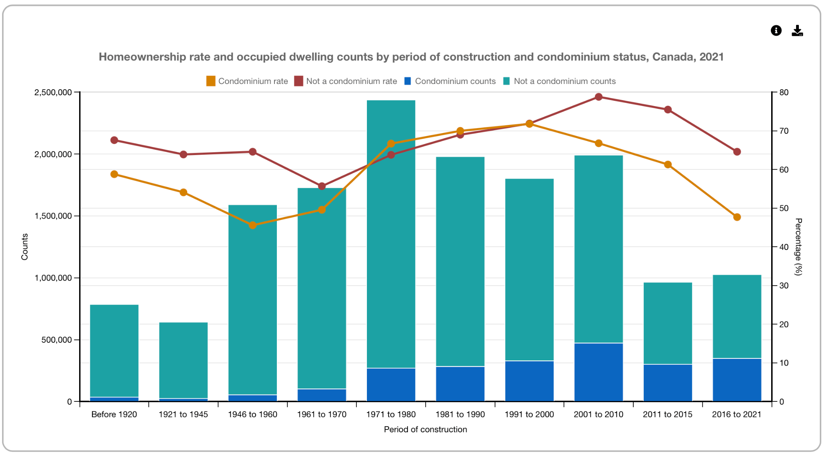
https://www12.statcan.gc.ca/census-recensement/2021/as-sa/fogs-spg/page.cfm?topic=7&lang=E&dguid=2021A000011124#
Appendix B
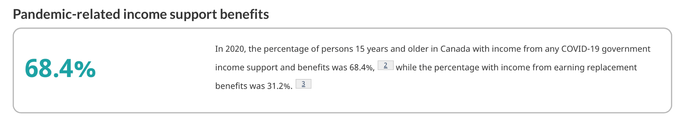
https://www12.statcan.gc.ca/census-recensement/2021/as-sa/fogs-spg/page.cfm?topic=5&lang=E&dguid=2021A000011124

Appendix C
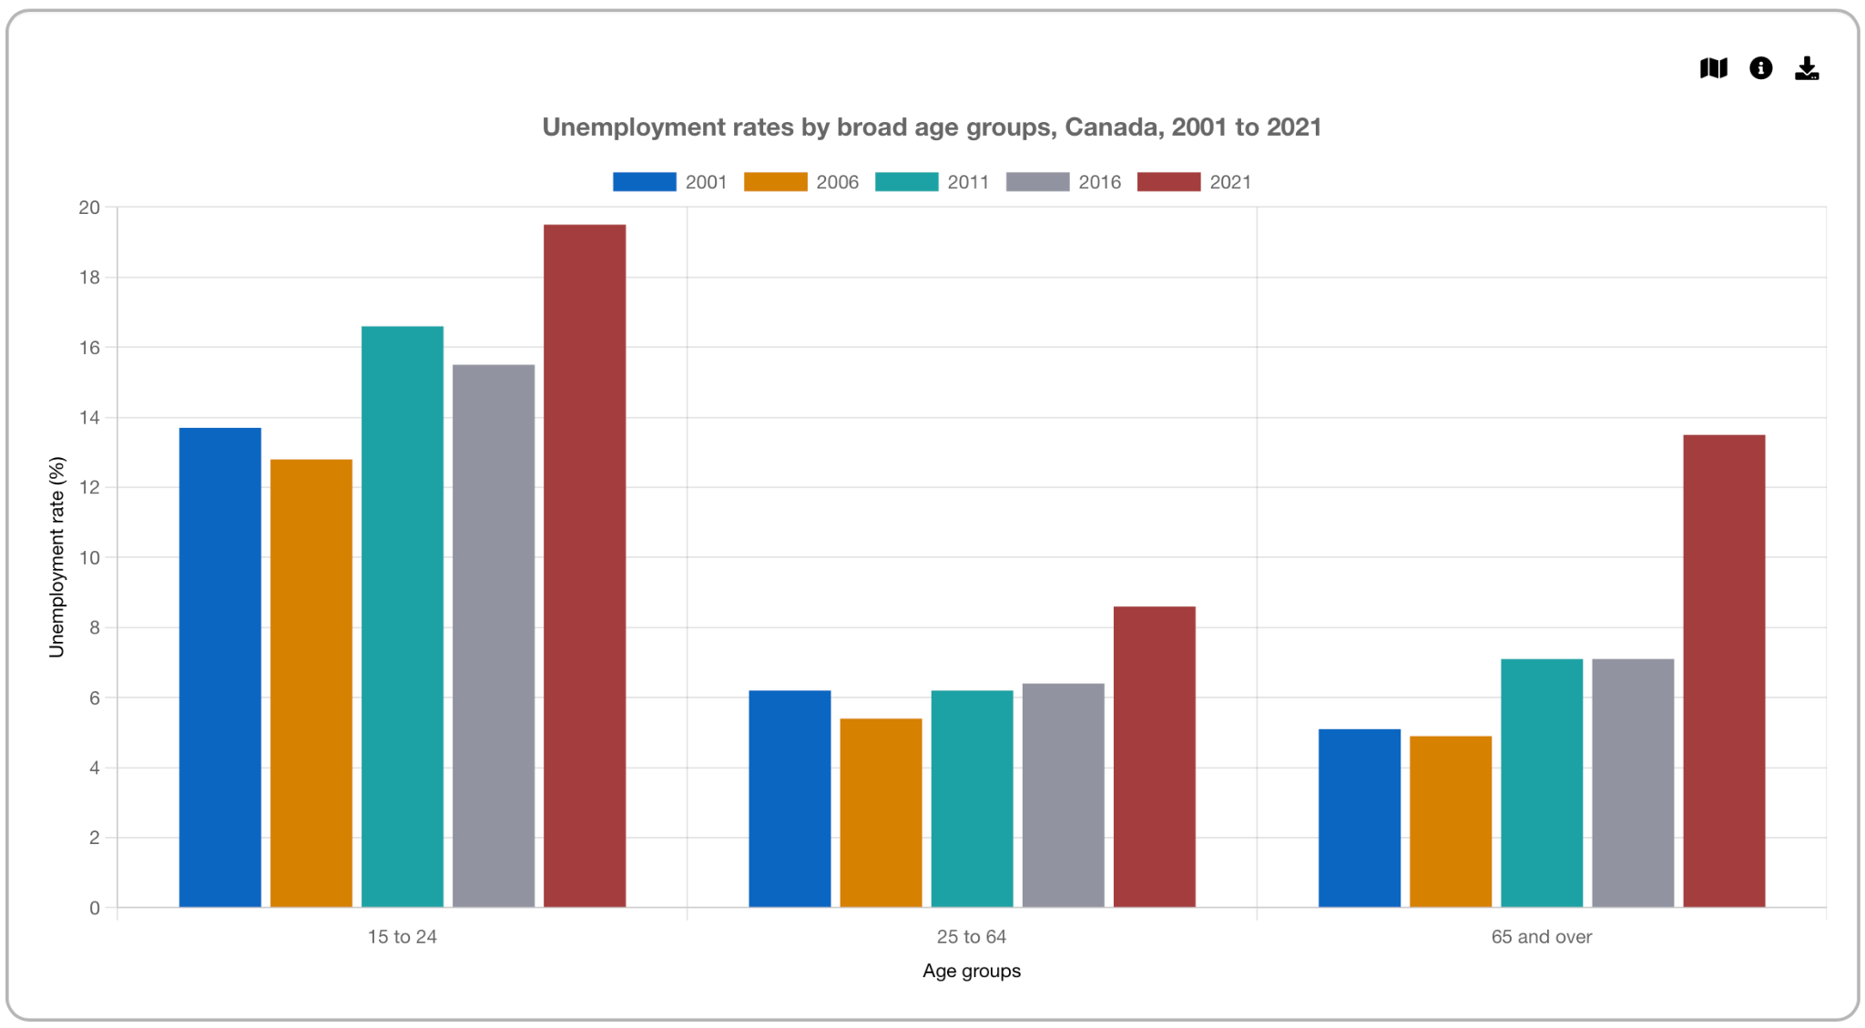

https://www12.statcan.gc.ca/census-recensement/2021/as-sa/fogs-spg/page.cfm?topic=12&lang=E&dguid=2021A000011124

Appendix D
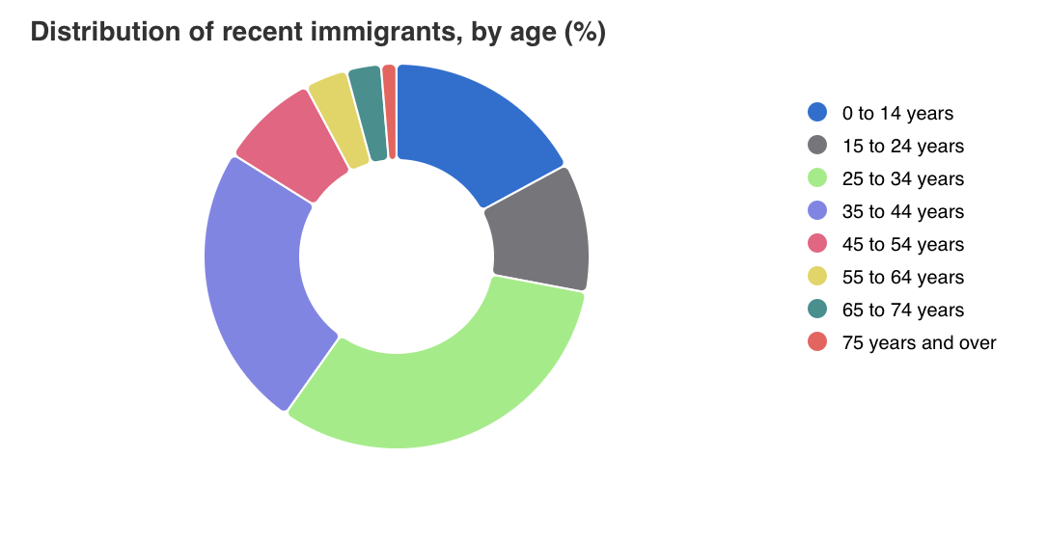

https://www12.statcan.gc.ca/census-recensement/2021/dp-pd/dv-vd/cpdv-vdpr/index-eng.cfm?locale=en-CA&statisticsProgramId=3902&activeIndicatorId=21160021&visualizationGeographyLevelId=2&focusGeographyId=2021A000011124

Appendix E
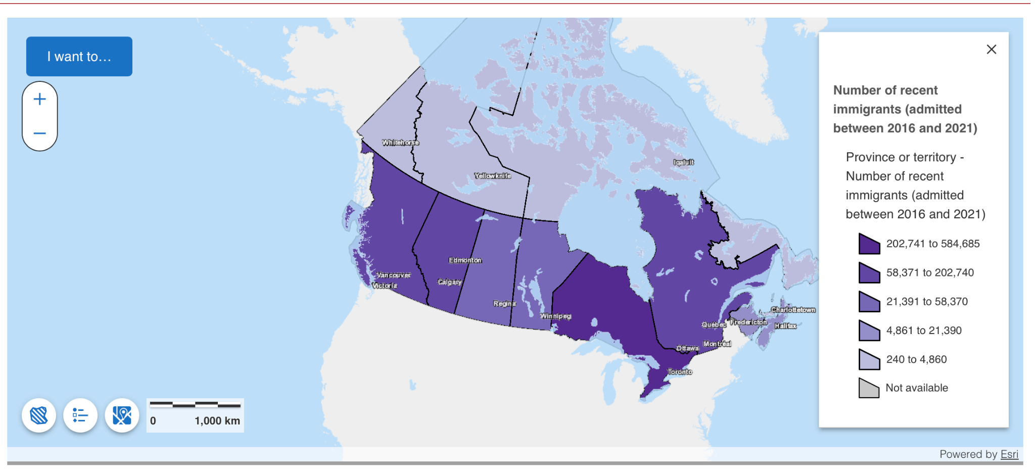

https://www12.statcan.gc.ca/census-recensement/2021/dp-pd/dv-vd/cpdv-vdpr/index-eng.cfm?locale=en-CA&statisticsProgramId=3902&activeIndicatorId=21160021&visualizationGeographyLevelId=2&focusGeographyId=2021A000011124

Appendix F
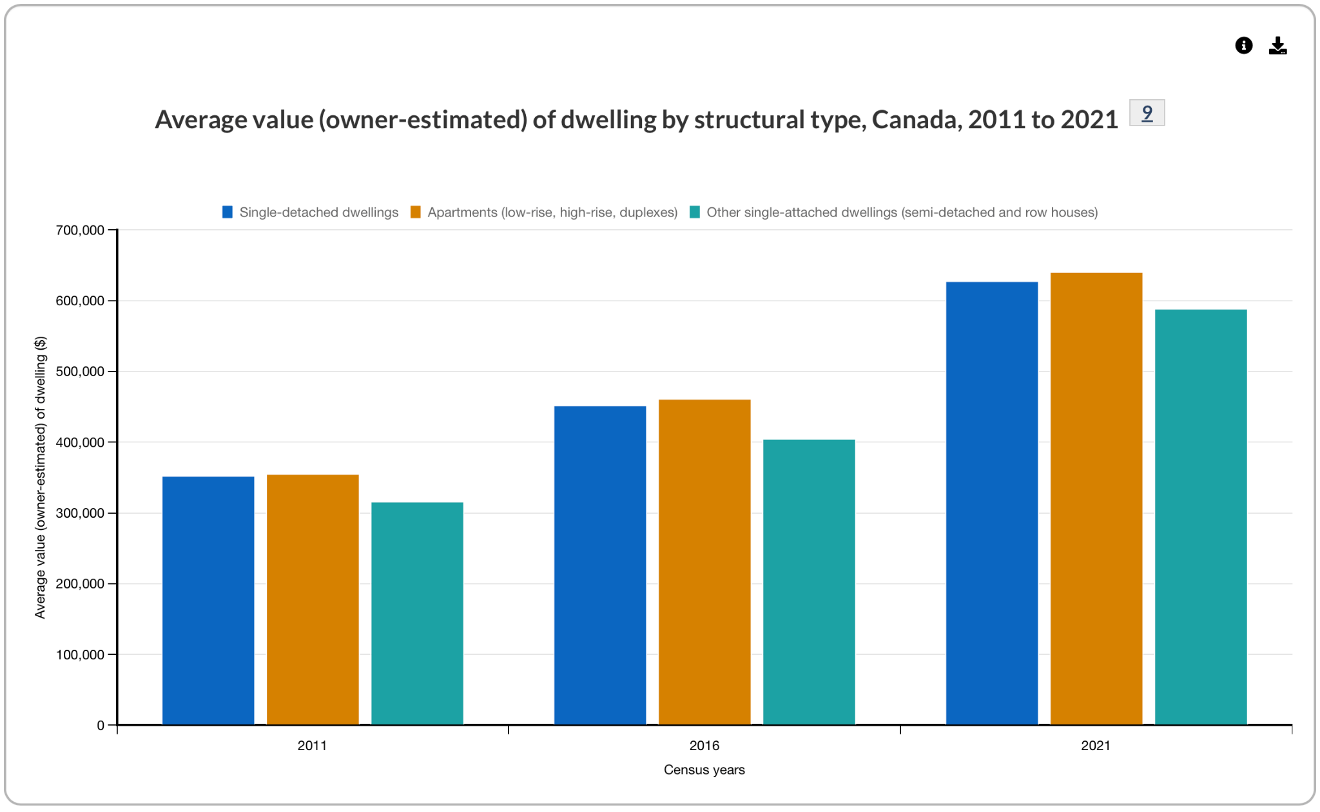
https://www12.statcan.gc.ca/census-recensement/2021/as-sa/fogs-spg/page.cfm?topic=7&lang=E&dguid=2021A000011124

Appendix G
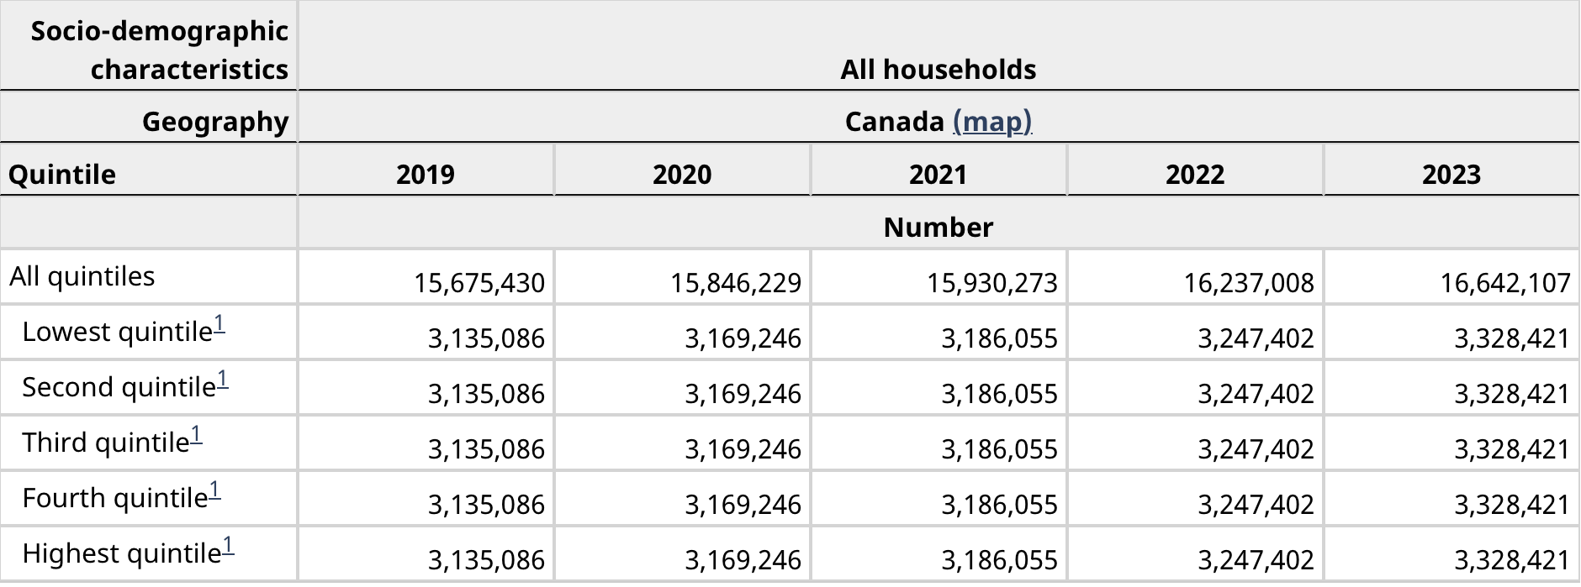

https://www150.statcan.gc.ca/t1/tbl1/en/tv.action?pid=3610010101

Appendix H
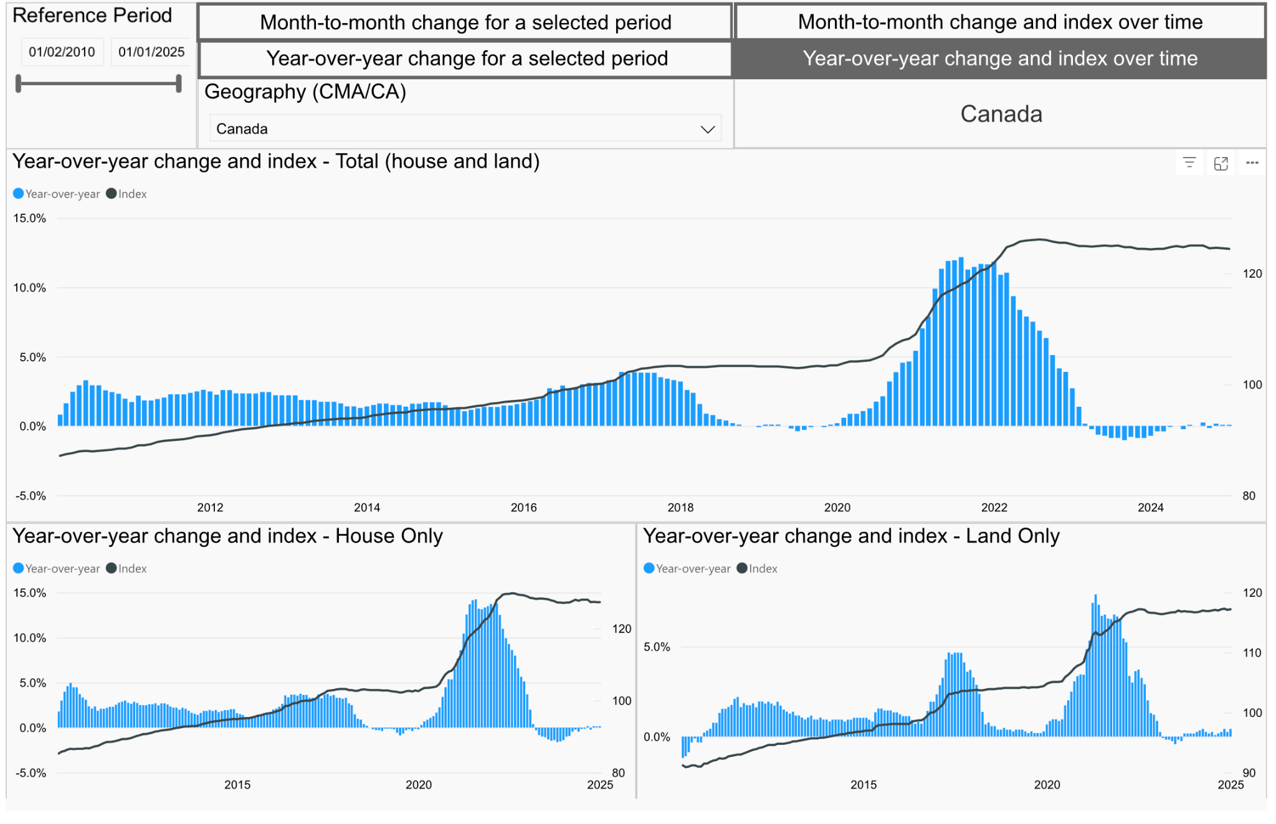

https://www150.statcan.gc.ca/n1/pub/71-607-x/71-607-x2019013-eng.htm

